**Smart Irrigation System**

Submitted in partial fulfillment of the requirements

Of the degree of

**Bachelor of Engineering**

by

Pooja Parab (SAP no:60001150031)

Hetvi Soni (SAP no:60001150054)

Naman Taneja (SAP no:60001150055)

Project Guide:

Prof. Darshana Sankhe



Electronics Engineering

Dwarkadas J. Sanghvi College of Engineering

Mumbai University

2018-2019

Certificate

This is to certify that the project entitled **Smart Irrigation System** is a bonafide work of **Hetvi Soni (60001150054)**submitted to the University of Mumbai in partial fulfillment of the requirement for the award of the degree of **Bachelor Of Engineering** in Electronics Engineering.

### Internal Guide Internal Examiner Prof. Darshana Sankhe

### Head of Department External Examiner

Prof. Prasad Joshi

### Principal

Dr. Hari Vasudevan

Project Report Approval for B. E.

This project report entitled ***Smart irrigation System*** by ***Hetvi Soni*** is approved for the degree of **Electronics Engineering**.

Examiners

1.---------------------------------------------

2.---------------------------------------------

Date:

Place:

Declaration

I declare that this written submission represents my ideas in my own words and where others' ideas or words have been included, I have adequately cited and referenced the original sources. I also declare that I have adhered to all principles of academic honesty and integrity and have not misrepresented or fabricated or falsified any idea/data/fact/source in my submission. I understand that any violation of the above will be cause for disciplinary action by the Institute and can also evoke penal action from the sources which have thus not been properly cited or from whom proper permission has not been taken when needed.

-----------------------------------------

Hetvi Soni

(60001150054)

Date:

Abstract

The smart irrigation system is the substitution for tradition farming. The focus area will be the parameter such as temperature, humidity, and soil moisture. We developed such a system which will help the farmer to know about certain weather condition such as temperature and humidity of his field in the home and he can control the water pump via soil moisture data.

Raspberry Pi is an important part of the system. Automated irrigation is developed to optimize water use for agriculture fields. Automation allows us to control appliances automatically.so the objective of the project is to control the water pump via webpage and also to visualize parameters like temperature and humidity using thing-speak IoT platform. we also deployed a linear regression algorithm for future predictions of the weather parameters.

|  |  |  |  |
| --- | --- | --- | --- |
| Contents | | | |
| CHAPTER  NO. | SECTION NO. | TOPIC | PAGE NO. |
|  |  | Certificate  Project Report Approval for B. E.  Declaration  Abstract | ii  iii  iv  v |
| 1. | 1.1  1.2 | Introduction | 1 |
| 2. |  | Review of Literature | 5 |
| 3. | 3.1  3.2  3.3  3.4 | System Model/Architecture  Soil Moisture Sensor  Temperature and Humidity Sensor  Raspberry Pi  Thingspeak IoT | 8  9  11  13  15 |
| 4. | 4.1  4.2  4.3 | Proposed System Implementation  Proposed System  Software used in the System  Code explanation | 17  18  19  21 |
| 5 |  | Results | 30 |
| 6 |  | Conclusions& Scope | 32 |
| 7 |  | REFERENCES & BIBLIOGRAPGHY | 34 |
| 8 |  | Acknowledgments | 36 |

**Chapter 1**

**Introduction**

**1.1. Irrigation System**

Water is the most significant issue on which the development of horticulture division to a great extent depends. Indian agribusiness segment is in desperate need of venture to meet the costs. To fuel the capital needs of the horticultural economy and furthermore to guarantee that the advantages of development permeate to base of the financial pyramid, cultivating must be anticipated as a road of venture for the urban population .The improvement in water system framework utilizing remote system is an answer for accomplish water protection just as progress in water system practices .Until as of late, India appreciated rich water assets. Due to populace development and overexploitation has prompted a circumstance where the interest for water is surpassing supply.

Amid mannual water system, the water prerequisite of plants/crops isn't checked. When the dirt is wet enough, water is still given. This water isn't consumed by the plants and therefore is squandered. Subsequently a framework is to screen the water necessities of the plant is required. Additionally Smart Irrigation System establishment implies diminished working of the farmer.

The proposed Smart Irrigation System consist of less hardware as compared to the previous models have been used in the past and hence it is compact as compared to the previous systems. It is more cost efficient, this claim can be made on the fact that the proposed system does not require heavy and expensive hardware. Also with the use of more efficient sensors in the system, the self life ,reliability and accuracy of the system increases. This type of automated irrigation consumes 40-50% less water as compared to the traditional system in use. Ideal growth condition is provided when small amount of water is been applied for a given amount of time.

This smart irrigation system allows the farmer to turn on/off the water pump according to his and requirements of the farm condition .It saves time and helps farmer access the field from remote location .also in this system we have detected the temperature and humidity of the field area ,using which machine learning algorithm can be deployed. so here we have used linear regression machine learning algorithm using which future prediction can be done and can be displayed on webpage designed which is easily accessed by the user.

**1.2.Linear Regression**

There are 2 sorts of supervised machine learning algorithm that are for the most part been utilized .They are Regression Algorithm and Classification calculation .The previous predicts consistent esteem yields while the last predicts discrete yields. For example, foreseeing the cost of a house in dollars is a relapse issue though anticipating whether a tumor is harmful or kindhearted is a grouping issue.

In this shrewd water system framework we have utilized straight relapse and executed it for both temperature and stickiness esteems and anticipated them utilizing ScikiLearn , which is a standout amongst the most prevalent machine learning libraries for Python.

So now the term linearity in polynomial math dependably alludes to a straight connection between at least two factors. Likewise in the event that we attract this relationship a two-dimensional space between two factors, we will get a straight line for the equivalent.

Straight relapse calculation plays out the assignment to foresee a reliant variable esteem (y) temperature dependent on a given free factor (x) stickiness. So utilizing this relapse method we discovered a straight connection among temperature and moistness. Thus, the name is Linear Regression. On the off chance that we plot the free factor (x) on the x-hub and ward variable (y) on the y-pivot, direct relapse gives us a straight line that best fits the information focuses

The equation of the line is  : **Y= mx + b**

*Here b is the intercept and m is the slope of the line.so basically,linear regression algorithm gives us the most optimal value for the intercept and the slope (in two dimensions).The variable x and y always remain the same as they the data variables and they can never be changed .The values that we can control are of the slope (m) and intercept(b).So basically what the linear regression algorithm does is it fits multiple lines on all data points and returns the line that gives the least error.*

**Chapter 2**

**Review of Literature**

The new situation of diminishing water, evaporating of waterways and tanks, flighty condition, presents a critical need for legitimate usage of water. To adapt up to this utilization of temperature and dampness, sensors are set at reasonable areas for observing the yields. After research in the rural field, specialists found that the yield of horticulture is diminishing step by step. Be that as it may, utilization of innovation in the field of horticulture assumes a significant job in expanding the creation just as in diminishing the labour. A portion of the examination endeavours is accomplished for the advancement of ranchers that give frameworks which utilize innovations accommodating for expanding the horticultural yield. The distributed computing gadgets make an entire processing framework from sensors to devices that watch information from the agrarian field and precisely feed the information into the vaults.

This thought proposes a novel technique for savy cultivation by connecting a keen detecting framework and shrewd water system framework through remote correspondence innovation. It proposes a minimal effort and productive remote sensor organize procedure to get soil moisture from different areas of the field and according to the need of yield water engine is empowered. It proposes a thought regarding how robotized water system framework was created to streamline water use for agriculture purposes. After broad research in the horticultural field, numerous specialists found that the farming zone and its profitability are diminishing constantly. With the Use of various innovation in the field of farming we can build the generation just as diminish manual endeavors. Some paper demonstrates the sprinkler empowering systems, conventions and design for a sprinkler which is broadly utilized for rural, planting, home, and office reason.

“A Low Cost Smart Irrigation Control System” is proposed by Chandankumar Sahu this experiment different wireless sensor are placed in the entire farm field. Each sensor is integrated with a wireless networking device and Data is collected by atmega328 microcontroller i.e. ardiuno UNO.

K S. Nemali proposed irrigation systems which are automated via information on volumetric water content of soil using dielectric moisture sensor. It is used for the purpose of controlling Actuation and saving water, instead of irrigation schedule at a specific time of the day, with a specific duration and according to soil moisture.

Supraha Jadhv proposed an automated irrigation system using raspberry pi and wireless sensor to control the activities of the dripping irrigation system efficiently.

Sebastian Hentzelt proposed a paper on the water distribution system and gave results to decompose the original nonlinear optimal control problem (OCP).

Joauin Gutierrez attempted a paper that research automated irrigation system using a GPRS module instead of the Raspberry piandwireless sensor network .

Ms. Deweshvreev Rane Proposed “Review paper based on Automatic Irrigation System Based on RF Module”. This paper is based on the RF module.RF module is used to transmit or received radio signal between two devices.It’s design is complex design because of the accuracy of the componentsandsensitivity of radio circuits.

Karan Kansara proposed “Sensor based automatic irrigation system with IoT”,this irrigation system is used a raingun pipe, one end connected to the water pump and another to the root of plant.it uses only soil moisture sensor and it does not provide water like sprinkler.

G. Parameswaran proposed “Ardiuno based smart irrigation system using Internet of Things”, the researcher has done the work using ardiuno controller without use of soil moisture sensors.

In GSM based Automatic Irrigation Control System for Efficient Use of Resources and Crop Planning by Using an Android Mobile Pavithra D. S, M. S .Srinath. States highlights of their framework. The framework bolsters water the board choice, utilized for observing the entire framework with GSM(RS-232) Module The framework consistently screens the water level (Water level Sensor) in the tank and give exact measure of water required to the plant or tree (crop). The framework checks the temperature, and mugginess of soil to hold the supplement synthesis of the dirt oversaw for appropriate development of plant. Low cost and compelling with less power utilization utilizing sensors for remote observing and controlling gadgets which are controlled through SMS utilizing a GSM utilizing android portable.

**Chapter 3**

**System Model/Architecture**

**3.1 Soil Moisture Sensor**

Soil moisture sensor measure the volumetric quantity of water in the soil. This sensor utilizes different properties of the soil like the dielectric obstruction, consistent, or communication with neutrons, as an intermediary for the dampness content as the gravimetric estimation of free soil moisture requires evacuating, drying and weighting. The connection between the deliberate property and soil moisture must be aligned. Reflective microwave radiation is influenced by the dirt dampness in horticulture. Convenient test instruments can be utilized by plant specialists. These sensors regularly allude to sensors that gauge volumetric content. They incorporate tensiometers and gypsum squares.

Soil moisture sensors regularly allude to sensors that gauge volumetric water content. Another class of sensors measure another property of dampness in soils called water potential; these sensors are normally alluded to as soil water potential sensors and incorporate tensiometers and gypsum squares

**3.1.1 Working of soil moisture sensor**

The soil moisture sensor consists of two probes which are introduced into the soil to measure the volumetric content of the soil. These probes allow the current to pass through the soil and measure the resistance of the soil. More the water in the soil, more the electricity conducted and so less resistance. Therefore the moisture level of the soil would be high. Conduction would be poor in dry soil and so there will be less water. The soil conducts less electricity which results in high resistance and so the moisture level is less.

There are two modes of conduction; analog mode and digital mode. We start by connecting it in the alaog mode and then we use it in the digital mode.

**3.1.2 Specifications**

The specifications of the soil moisture sensor are as follows:

Table 3.1

|  |  |
| --- | --- |
| **Specifications** | **Description** |
| Input voltage | 3.3 – 5V |
| Ouput voltage | 0 - 4.2V |
| Input current | 35mA |
| Output signal | Both analog and digital |

**3.1.3 Pin Out – Soil Moisture Sensor**

The soil Moisture sensor FC-28 has four pins:

1. VCC: For power
2. A0: Analog output
3. D0: Digital output
4. GND: Ground

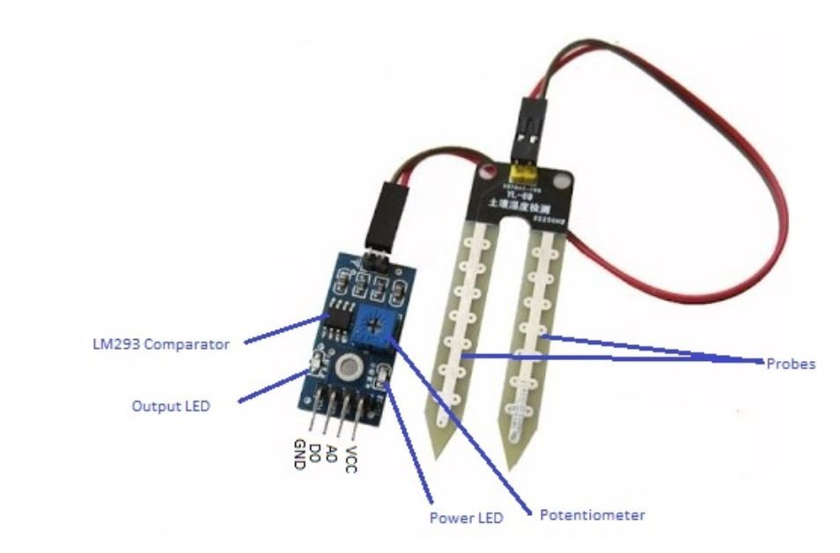

Fig 3.1 soil moisture sensor

**3.2 Temperature and Humidity Sensor**

The senor used here is a DHT11 temperature and humidity soil moisture sensor which features a calibrated digital output and is integrated with a high performance 8 bit microcontroller. It is highly reliable and shows great long term stability. There is a resistive element and a sensor for wet NTC temperature measuring devices. Various advantages to this sensor are fast response, outstanding quality and high performance.

These sensors are small in size, low power, has signal transmission distance of up to 20 meters enables a variety of applications. The product is a 4 pin single row pin package which provides convenient connection and would let special packages to be sent according to the needs of the user. The DHT11 sensors have a calibration coefficient which detects the signals in the process.

**3.2.1 DHT11** :

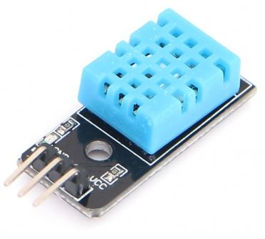

Fig 3.2 DHT11 sensor

**3.2.2 Pin Out of DHT11:**

Table 3.2

|  |  |
| --- | --- |
| Supply voltage | +5v |
| Temperature range | 0-50 °C error of ± 2 °C |
| humidity | 20-90% RH ± 5% RH error |
| interface | Digital |

**3.3 IoT Platform (Thingspeak):**

Internet of things (IoT) deals with the connection of various embedded devices and the Internet. These devices often communicate with people and other things providing sensor data to cloud storage and cloud computing resources where the data is processed and analysed to gain important insights. One f the advantages is cheap cloud computing power and increased device connectivity.

ThingSpeak is an open source IoT application and API is used to store and retrieve data from the ThingSpeak using the HTPP protocol over the internet or via a Local Area Network. Using this we can visualize the interpretation of collected data



Fig 3.3 thingspeak logo

Internet of things (IoT) deals with the connection of various embedded devices and the Internet. These devices often communicate with people and other things providing sensor data to cloud storage and cloud computing resources where the data is processed and analysed to gain important insights. One f the advantages is cheap cloud computing power and increased device connectivity.

ThingSpeak is an open source IoT application and API is used to store and retrieve data from the ThingSpeak using the HTPP protocol over the internet or via a Local Area Network. Using this we can visualize the interpretation of collected data.

**3.3.1 Data Visualization**

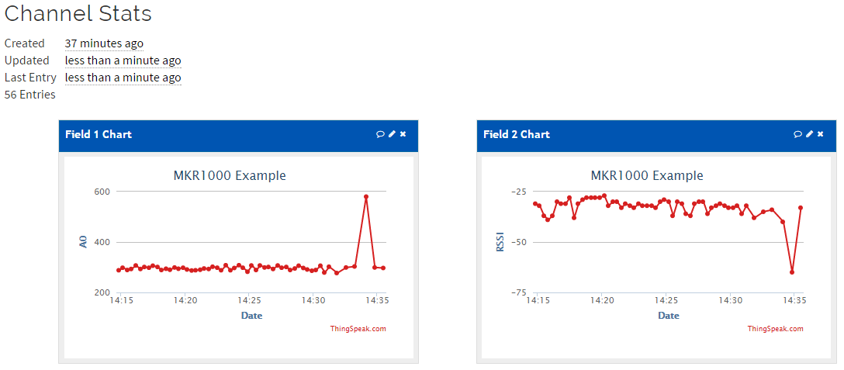

Fig 3.4 data visualization on thingspeak

**3.4 Raspberry Pi**

The Raspberry Pi 3 is a small, powerful and lightweight ARM based computer which can do many of the things a desktop PC can do.

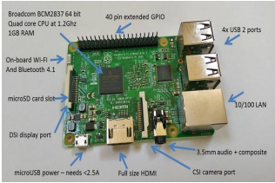

Fig 4.2 Raspberry PI

Raspberry Pi has got graphics capabilities and HDMI video output make it ideal for multimedia applications such as media centers and narrowcasting solutions. The Raspberry Pi is based on a Broadcom BCM2835 chip. It does not feature a built-in hard disk or solid-state drive like general computing devices, instead relies on an SD card for booting and long-term storage. Also other big advantage of raspberry pi is that it has got various software development tools platform can be implemented on it.

Raspberry pi 3 has got 40 GPIO pins though which various sensors can be connected to the Pi.

**Chapter 4**

**Proposed System Implementation**

**4.1 Proposed system**

In this proposed system, the heart of the system is Raspberry Pi. To it we have connected two sensors as shown in figure. Soil moisture sensor will detect the moisture of the soil and indicate the logic accordingly to the raspberry pi. Temperature and Humidity Sensor will detect the temperature and humidity respectively. This system will communicate wirelessly with the farmer via webpage .

Thingspeak IoT platform has a free cloud storage and using this IoT platform available data through sensors will get stored into cloud .The stored data into cloud is useful to visualize the data effectively. Also using Scikit learn python library. We can deploy suitable algorithm to the data given by sensor. By using this algorithm and analysis we can predict the weather conditions of the farm.

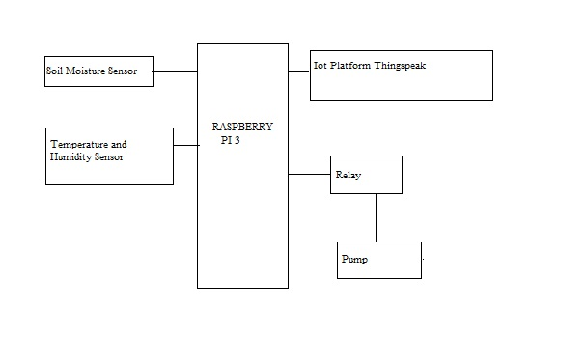

Fig 4.1 Proposed system

The Raspberry Pi cannot directly drive the relay. It has only 5 volts or 3.3 V. So in order to drive a submeriazied pump we need a relay In that case we need a driver circuit .We are using here 1 relay to switch on Water motor .

**4.2 Softwares used in this project**

Python is an universally useful programming language. Python is made by Guido van Rossum and was first discharged in 1991.

Python has a structure logic that stresses code coherence, eminently utilizing huge whitespace. It gives builds that empower clear programming on both little and extensive scales. Van Rossum drove the language network until July 2018.

Python is powerfully composed and trash gathered. It underpins different programming ideal models, including procedural, object-arranged, and practical programming. Python includes an extensive standard library, and is alluded to as "batteries included".Python translators are accessible for some working frameworks. CPython, the reference execution of Python, is open-source programming and has a network based improvement model. Python and CPython are overseen by the non-benefit Python Software Foundation.

.



Fig 4.1 python logo

**4.2.1 Libraries used with python**

**flask**

The microframework Flask is based on the Pocoo  projects Werkzeug and Jinja2. Werkzeug is a utility library for the Python programming language, in other words a toolkit for Web Server Gateway Interface (WSGI) applications, and is licensed under a BSD License.



**Scikit Learn**

Scikit-adapt (in the past scikit learn) is a free programming AI library for the Python programming language.

It highlights different arrangement, relapse and bunching calculations including bolster vector machines, irregular woods, inclination boosting, k-means and DBSCAN, and is intended to interoperate with the Python numerical and logical libraries NumPy and SciPy.

Scikit-learn gives a scope of directed and unsupervised learning calculations through a steady interface in Python.It is authorized under a tolerant streamlined BSD permit and is circulated under numerous Linux appropriations, empowering scholastic and business use.

We need to install SciPy (Scientific Python) before we use the SciKit learn as the libraries are built upon this. This stack includes:

* NumPy- describes Base n dimentional array package
* Scipy- describes fundamental library for scientific computing
* Matplotlib- describes comprehensive 2D/3D plotting.
* Ipython- describes enhanced interactive console
* Sympy- describes Symbolic mathematics
* Pandas- describes data structures and analytics

SciKits are extensions are modules for conventional ScyPy care. The module provides learning algorithms and are so named as SciKit-learn.

There is a level of robustness and support required for the use of libraries in the production system. Therefore there is a deep focus on the ease of use, code quality, collaboration, performance and documentation.

**4.3Code:**

The dataset contains information on weather conditions recorded on each day at farm using temperature and humidity sensor. Information includes temperatures and humidity of the day.

So our task is to predict the maximum and minimum temperature taking input feature as temperatureand humidity of current day.

**Import all the required libraries :**

*import numpy as np*

*import pandas as pd*

*import numpy as np*

*import math*

*import sklearn*

*from sklearn. metrics import mean_squared_error,r2_score,mean_absolute_error*

*import matplotlib. pyplot as plt*

*import seaborn as sb*

*from sklearn import preprocessing*

*import csv*

*import matplotlib.pyplot as plt*

*import seaborn as seabornInstance*

*from sklearn.model_selection import train_test_split*

*from sklearn.linear_model import LinearRegression*

*from sklearn import metrics*

**The following command imports the CSV dataset using panda**s:

*pd.read_csv*

**The following commands are used to find the co-variance and co-relation between X-axis and Y-axis:**

*data.cov()*

*data.corr()*

**The following commands we are using to print the current temperature and humidity values**:

*print("Scatter plot of field1 and field2 attributes")*

*plt.scatter(data.field1,data.field2)*

*plt.xlabel("Temperature")*

*plt.ylabel("humidity")*

*Scatter plot of field1 and field2 attributes*

*Text(0,0.5,'humidity')*

**The following commands we are using extract minimum and maximum values of current data:**

*max1= data.field1.max()*

*min1= data.field1.min()*

*max2=data.field2.max()*

*min2= data.field2.min()*

**The following command we are using to reshaping the 1-D graph into 2-D graph:**

*x= data['field2'].values.reshape(-1,1)*

*y = data['field1'].values.reshape(-1,1)*

**Creating test set and training set:**

*x_train, x_test, y_train, y_test = train_test_split(x, y, test_size=0.2, random_state=0)*

**we are applying pre-defined regression function on the trained** **dataset:**

*regressor = LinearRegression()*

*regressor.fit(x_train, y_train)*

*LinearRegression(copy_X=True, fit_intercept=True, n_jobs=1, normalize=False)*

**The following command we are using to print the future temperature values:**

*df1=pd.DataFrame({'Actual1': y_test.flatten(), 'Predicted1': y_pred.flatten()})*

**The step is to evaluate the performance of our algorithm.**

Now it is important for us check the correct performing of our algorithm, for doing so we need to find the values of error in the predicted dataset .For doing so we need to calculate the following error.

**1.Mean Absolute Error (MAE):**

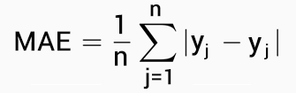

**2.Mean Squared Error (MSE):**

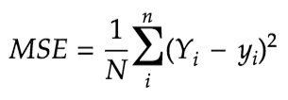

**3.Root Mean Squared Error (RMSE):**

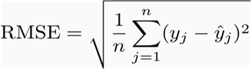

But we don’t have to perform this calculations manually.

The scikit learn library comes with certain predefined function to calculate this errors value for us.

We can find the values of this errors for our test data using functions:

*metrics.mean_absolute_error(y_test, y_pred)*

*metrics.mean_squared_error(y_test, y_pred))*

*np.sqrt(metrics.mean_squared_error(y_test, y_pred)*

The below given myAPI code was generated by the channel and the following commands were used to send data from temperature and humidity sensor to thingspeak channel

*myAPI = '5QTYDNRHSJ5RESA5'*

*baseURL = 'https://api.thingspeak.com/update?api_key=%s' % myAPI*

*.*

**Commands to import from python library for creating the webpage :**

*from flask import Flask, render_template, redirect, url_for*

*import psutil*

*import datetime*

*import water*

*import os*

**calling the flask function:**

*app = Flask(__name__)*

**Making a template**:

*deftemplate(title="HELLO!", text=""):*

*now = datetime.datetime.now()*

*timeString = now*

*templateDate = {'title' : title,time' :timeString'text' : text }*

*return templateDate*

**@app.route()** is a decorator, it has been defined to call in the function you give it at some point during the execution of its internal commands. The input argument it takes is what is called a url rule, which is basically like a pattern that an incoming request's url has to match in order to trigger the function you defined for the route to take.

**Command used for calling template on webpage :**

*@app.route("/")*

**Command used for checking status of farm on webpage :**

*@app.route("/last_watered")*

**Command used for turning motor on/off from webpage :**

*@app.route("/sensor")*

**Command used for turning pump off from webpage :**

*@app.route("/water")*

**Command used for turning pump on automatically from webpage :**

*@app.route("/auto/water/<toggle>")*

**Chapter 5**

**Results**

**Temperature predicted values using linear regression algorithm**:

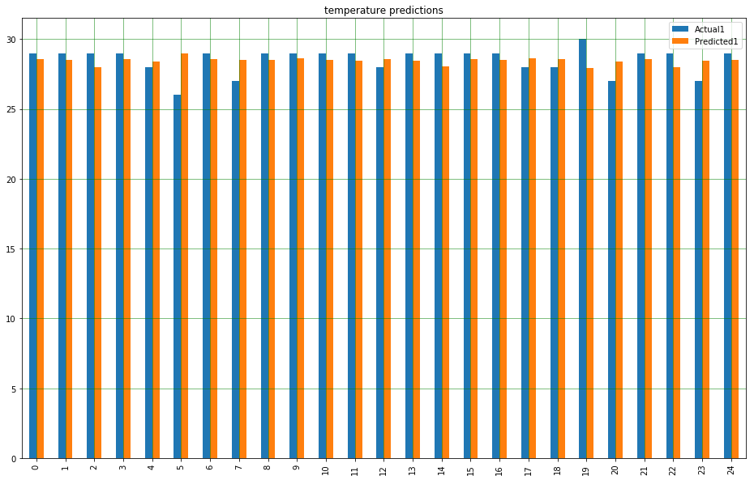

**Humidity predicted values using linear regression algorithm:**

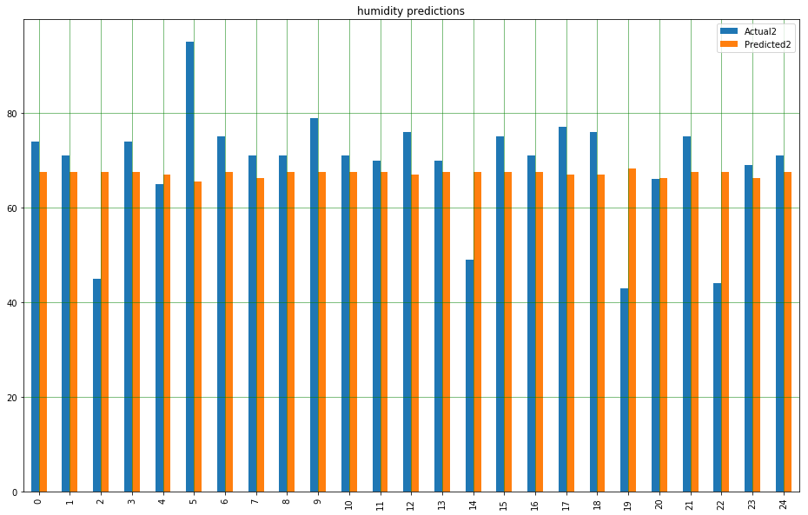

**Senor data on thinspeak IoT platform:**

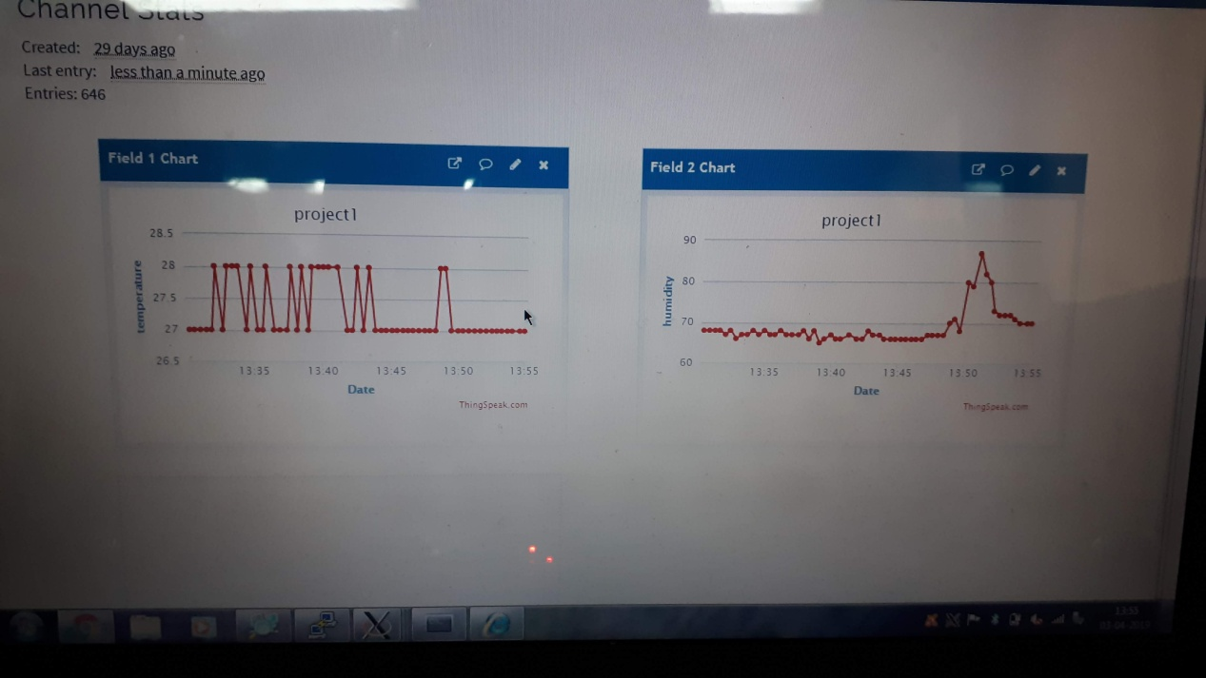

**Webpage through which farmer can access the farm and operate the motor:**

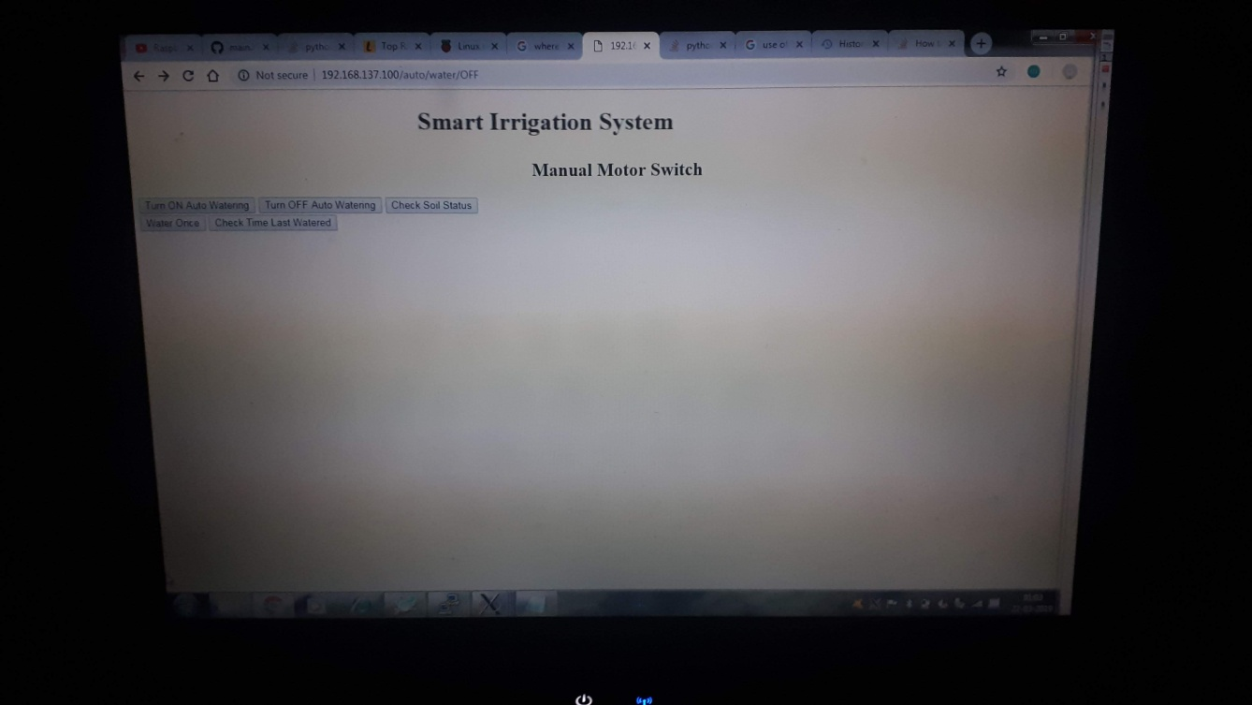

**Chapter 6**

**Conclusion and Scope**

The adoption of Iot technology has immensely gone up in the last few years. The concept of smart irrigation is a new one and is coming up. Most of the smart irrigation setups have a lot of complex features and capabilities. These kind of setups are great for large scale operations like watering a golf course etc but are way too elaborate for a small farm owner and an independent gardener. We are required to raise awareness and increase familiarity amongst people since user inputs such as soil type, crops, surface slope etc are critical for the performance of such systems. These kind of systems are also used for error correction and the efficiency is increased.

These smart irrigation systems are amazing as they can be used for optimal utilization of water and ensures uniform watering of plants. By using high end sensors one can also factor in the climatic parameters for efficient predictions. Manual labor and time wastage is certainly reduced. With smart decision making capabilities the face of irrigation could be changed altogether. This field is evolving at a very fast rate and it would be very intriguing to track further developments in the above field over the foreseable future.

**Chapter 7**

**Reference**

[1] Chandankumar Sahu, Pramitee Behera. 2015 A Low Cost Smart Irrigation Control System IEEE Sponsored 2nd International Conference on Electronics and Communication System (ICECS).

[2] Krishna S. Nemali, Marc W. van Iersel. Nov. 2006 An automated system for controlling drought stress and irrigation in potted plants, Scientia Horticulturae, pp: 292-297, Vol. 110, no. 3, pp. 292–297,

[3] Suprabha Jadhav,Shailesh Hambarde. 2013 Automated Irrigation System using Wireless Sensor Network and Raspberry pi, International Journal of science and research (IJSR). [4] Hentzelt1, S., Klingler, A. and Graichen, K. 2014. Experimental results for distributed model predictive control applied to a water distribution system In: IEEE International Symposium on Intelligent Control (ISIC) IEEE Multi-conference on Systems and Control.

[5] Gutierrez, J., Francisco, J. Villa-Medina Nieto-Garibay, A., and Angel, P.G. 2013. Automated Irrigation System Using a Wireless Sensor Network and GPRS Module. In: IEEE Transactions on Instrumentation and measurement.

[6] Rane, D., Indurkar, P., and Khatri, D. M.. 2015 REVIEW PAPER BASED ON AUTOMATIC IRRIGATION SYSTEM BASED ON RF MODULE In IJAICT Volume 1, Issue 9.

[7] Kansara, K., Zaveri, V., Shah, S., Delwadkar, S., Jani, K. 2015 Sensor Based Automated Irrigation System with IOT In IJCSIT, Vol.

**Chapter 8**

**Acknowledgement**

With the completion of this project, there is a sense of satisfaction but without the constant support of some people it would not have been possible. All our combined efforts resulted in making this project a success.

Keeping in mind the force that guides us all, we express our deepest gratitude to the almighty God for holding our hands and guiding us throughout our lives.

We are really grateful to our guide Prof. Darshana Sankhe for her guidance and constant supervision. She always provided us with the necessary information and cleared all our doubts regarding the project.

We are also indebted to our guide Prof. Prasad Joshi, Head Of Department, for his expert opinions, support and encouragement at every step.

We are really thankful to all the teaching staff of Electronics Department for the constant support and encouragement which really helped us throughout the process. We would like to extend our sincere gratitude to all the staff in the laboratory for their timely support.

We are very happy to acknowledge our gratitude to our parents for their constant support and encouragement and last but not the least, friends and well wishers for their help and cooperation and solutions to all our problems throughout the process.



